Market Intelligence Research Brief
Udacity Nanodegree Project 2: Market Intelligence Agent (Amazon Quick Suite)
Date | October 3, 2026
Topic/Company | GenAI Labs Market Intelligence Analysis (19,329 products, 2022–2025)

1. Research Objective
The business question or decision this market intelligence supports.
Objective: Which areas of the Generative AI product market (2022–2025) are most and least crowded, how are pricing and API access distributed, and which domain × intelligence-type intersections should GenAI Labs research further before making any product or market-entry decision? The work separates verified dataset observations from interpretations and external signals, so leadership knows what is established and what still needs validation.

2. Scope of Research
What was included and excluded.
- Markets or industries covered: Generative AI products across 8 primary domains (General/Other, Image/Design, Automation, Coding, Video, Writing, Research/Search, Audio) and 7 intelligence types (Multimodal Generative AI, Computer Vision/Diffusion, LLM, Autonomous Agent, Code Intelligence, Speech-to-Text/TTS, Generative Video). Source: Kaggle “Generative AI Market & Competitive Intelligence Dataset” (19,329 records, 12 fields).
- Competitor types included: The 18,479 distinct developers/companies in the dataset, from individual creators to established AI companies. The dataset does not separate enterprise from consumer products.
- Timeframe considered: Product release years 2022–2025. Post-2025 conditions are not reflected. Quick Research external signals were gathered on September 23, 2026.
- Key constraints: Limited Quick Research allocation, so effort went to one focused research report plus full-dataset verification. Only the 12 dataset fields are available. Context_Window is missing for 20.06% (3,877) of records, and each product has only one accessibility channel.
- Explicitly excluded (and why): Revenue, market share, profitability, adoption/retention, geography, enterprise-vs-consumer split and post-2025 conditions, because the dataset contains no such fields. Excluding them means every finding describes product representation, not commercial performance or demand.

3. Research Approach
How AI-assisted research was conducted.
- Types of questions asked: (a) Structure: how are products distributed across domains, intelligence types, pricing models and API availability? (b) Trend: how did launches change 2022–2025? (c) Cross-tab: which domain × intelligence-type cells are populated or empty? (d) Verification: do Quick Research’s sample-based claims hold across all 19,329 records?
- How research effort was prioritized: Phase 1: one broad Quick Research report to generate hypotheses and external context (Figures 12–13). Phase 2: full-dataset verification in Quick, spending effort first on the claims that drive the biggest decisions (concentration and empty cells, then pricing, API, Video/Audio) (Figures 14–31). Phase 3: contradictions between Quick Research and the full dataset were flagged and resolved in favor of the full dataset. Low-value questions (e.g., Accessibility channel, Popularity_Votes) were deprioritized.
- Tools used within Amazon Quick Suite:
Tool | What it was used for | Output it produced
Quick Research | Broad market-intelligence report on the uploaded dataset with external context | Research Report v1 (Figure 13)
Quick Chat (Q) / agent chat | Iterative questions and full-dataset verification queries (counts, cross-tabs, reconciliations) | Verification outputs (Figures 14–31)
Quick Sight Analysis & Dashboard | Visual analysis of distributions, cross-tab and launches | Six visuals (Figures V1–V6 in Section 5)
Spaces / Agent | Dataset reference, outputs, analysis and brief organized for stakeholder review | See Appendix B

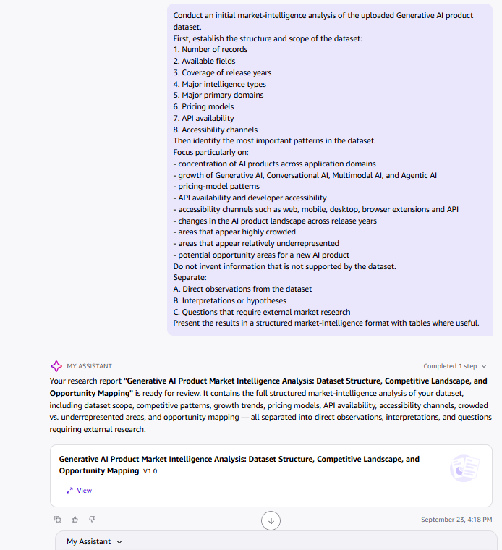
Figure 12. Quick Research prompt (Sept 23, 2026) separating direct observations, interpretations and questions needing external research. Supports Section 3.
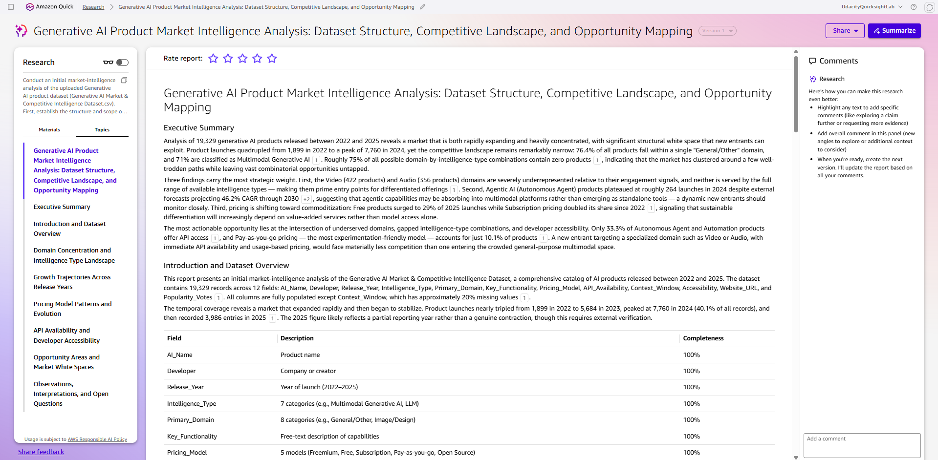
Figure 13. Quick Research report v1: external-context claims (e.g., agentic AI forecast, “Free surged to 29%”, “Subscription doubled”) that were tested in Phase 2. Supports Insights 2–4.

4. Key Market Insights
Five synthesized insights. All dataset figures were verified on October 3, 2026 against all 19,329 records (no sampling, no filters).

Evidence Traceability Matrix
Insight | Metric | Verified result | Screenshot evidence
1. Structural gaps | 8 × 7 Domain × Intelligence cross-tab | 56 cells; 19 populated; 37 empty (66.07%) | Figs 16–21, V3
2. Concentration | Domain and type frequencies | General/Other 14,768 (76.40%); Multimodal 13,722 (70.99%) | Figs 15A–18, V1–V2
3. Pricing | Pricing_Model frequency | Freemium 7,665 (39.66%); 5 categories; no Enterprise | Figs 22–24, V4
4. API access | API_Availability frequency | Yes 9,792 (50.66%); No 5,709 (29.54%); Waitlist 3,828 (19.80%) | Figs 25–27, V5
5. Video/Audio | Domain totals and cell detail | Video 422 (2.18%); Audio 356 (1.84%); combined 778 (4.03%) | Figs 28–31, V1, V3

Insight 1: Two-thirds of possible domain × intelligence-type combinations are empty
- Insight Summary: Of 56 possible combinations, 37 (66.07%) contain zero products. The dataset is concentrated in a few intersections. This is a verified observation of representation gaps; it does not prove unmet demand, because empty cells may reflect technical infeasibility, low demand or classification artifacts.
- Supporting Evidence or Signals: 19 populated cells, 37 zero-count cells, 56 of 56 cells matched direct queries, 0 discrepancies (Figs 16–21). Largest cell: General/Other × Multimodal = 13,367 products (69.2% of all records); the five largest cells hold 86.3% of products. Quick Research reached the same “roughly 75% empty” direction on a sample (Fig 13); the full dataset gives the exact 66.07%.
- Why This Insight Matters: It gives leadership a map of where the dataset has no products, i.e., where to point customer-demand and feasibility research first. It is a starting list for investigation, not a list of opportunities.
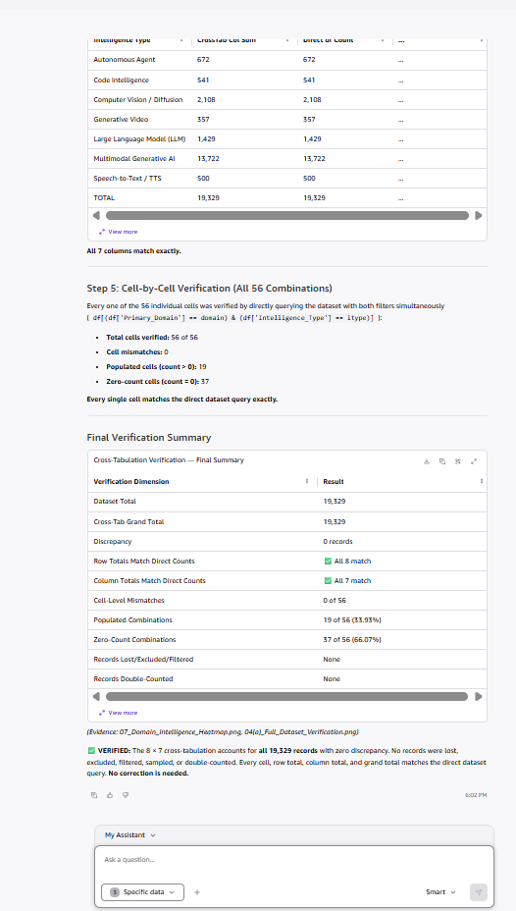
Figure 21. Cell-by-cell verification: 56 of 56 cells matched, 19 populated, 37 zero-count (66.07%). Supports Insight 1.

Insight 2: General/Other and Multimodal Generative AI dominate the landscape
- Insight Summary: 76.40% of products (14,768) are in the General/Other domain and 70.99% (13,722) are Multimodal Generative AI. These two labels define the center of gravity of the dataset, but they may mask sub-segments, and product counts are not revenue or market share.
- Supporting Evidence or Signals: Next-largest domain is Image/Design at 9.12% (1,763); the other six domains are each below 3.5%. Next-largest intelligence type is Computer Vision/Diffusion at 10.91% (2,108) (Figs 15A–15B, V1). Annual launches: 1,899 (2022), 5,684 (2023), 7,760 (2024), 3,986 (2025) (V6). External signal (Quick Research, Sept 23, 2026; verified Oct 3, 2026): Grand View Research, “Enterprise Agentic AI Market Size & Share Report, 2025–2030” (published April 2025; page last updated July 2026; grandviewresearch.com/industry-analysis/enterprise-agentic-ai-market-report) estimates the enterprise agentic AI market at USD 2.6B in 2024, USD 5.3B in 2026 and USD 24.5B by 2030, a 46.2% CAGR (2025–2030). This is context only and covers enterprise agentic AI revenue, a narrower and different measure than this dataset’s product counts. In the dataset, Autonomous Agent products peaked at 264 launches in 2024 and total 672 (3.48% of all products).
- Why This Insight Matters: A general-purpose multimodal entry would compete with more than 13,000 listed products. Specialized domains face far fewer listed competitors, but whether that means easier entry depends on demand, which the dataset cannot show.
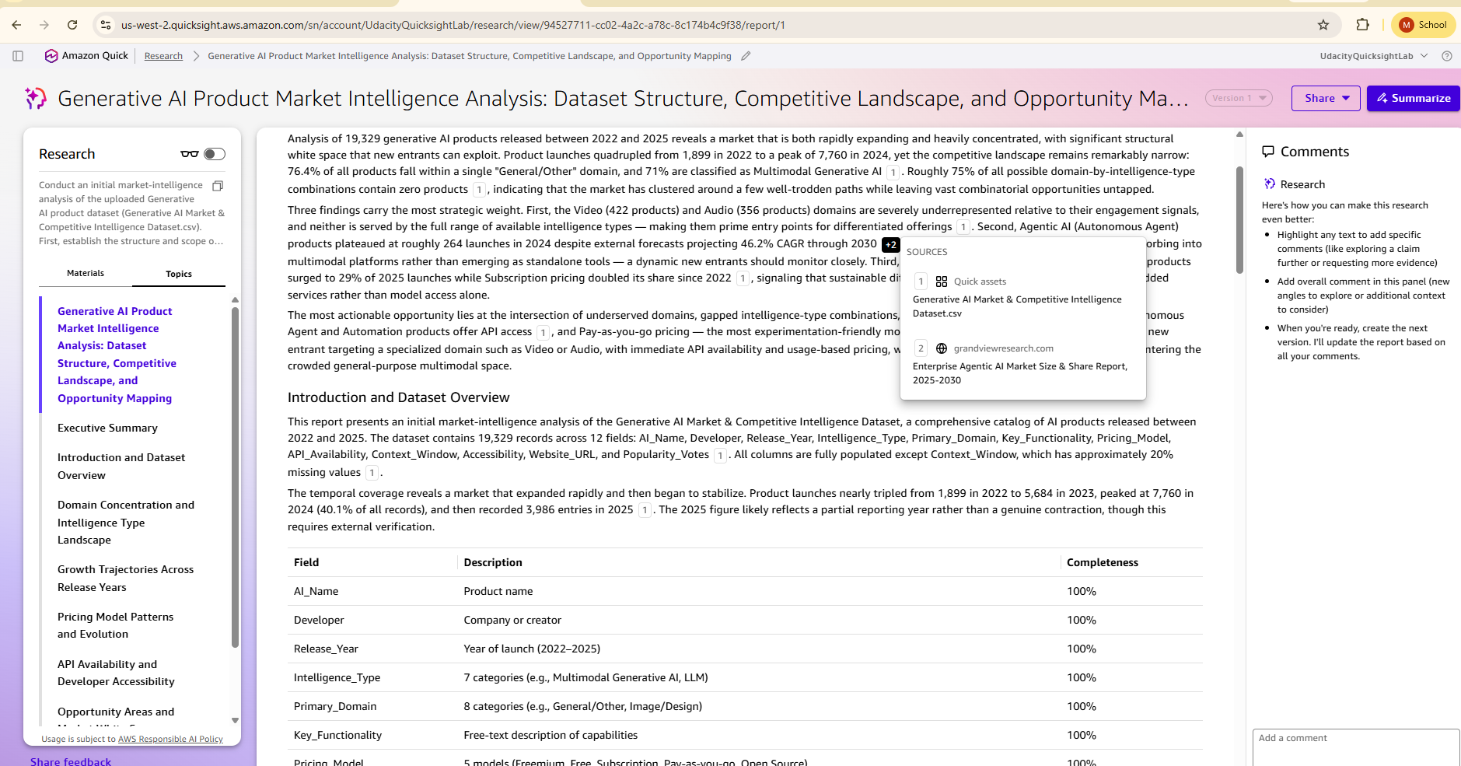
Figure 13B. Quick Research source panel: citation 2 is Grand View Research, Enterprise Agentic AI Market Size & Share Report, 2025-2030. Supports the external signal in Insight 2.
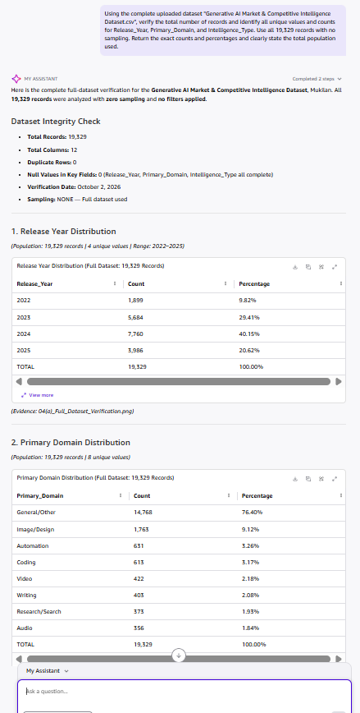
Figure 15A. Record count and Primary_Domain distribution in Quick. Supports Insight 2.

Insight 3: Freemium is the most common pricing model, and pricing is stable across years
- Insight Summary: Five pricing categories exist: Freemium 39.66% (7,665), Free 20.31% (3,926), Subscription 20.05% (3,876), Pay-as-you-go 10.14% (1,960), Open Source 9.84% (1,902). There is no Enterprise category. Quick Research’s sample-based claims of dramatic pricing shifts are not supported by the full dataset.
- Supporting Evidence or Signals: Counts reconcile to 19,329 (Figs 22–24, V4). Quick Research vs. full dataset: the report said Subscription “doubled its share” and Free “surged to 29% of 2025 launches” (Fig 13). A year-by-year recheck of the CSV (pandas, outside Quick) shows Subscription at 20.6% in 2022 and 19.3% in 2025, and Free at 19.7% of 2025 launches.
- Why This Insight Matters: Freemium is the most frequently represented model, but frequency does not show which model earns revenue. The mismatch with Quick Research shows why AI-generated trend claims must be checked against the full data before reaching leadership.
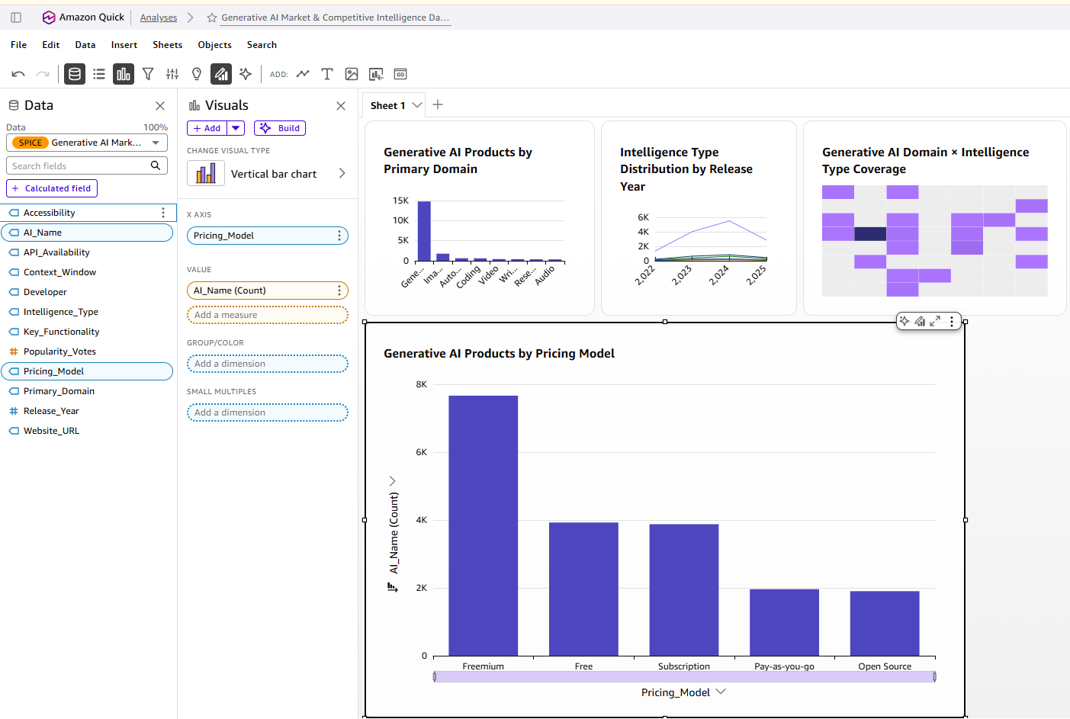
Figure V4 (08). Pricing model distribution in Quick Analysis. Supports Insight 3.

Insight 4: About half of listed products offer API access
- Insight Summary: 50.66% of products offer an API (9,792), 29.54% do not (5,709) and 19.80% are on a waitlist (3,828). API availability signals developer accessibility but not API quality or actual use.
- Supporting Evidence or Signals: No nulls; counts reconcile to 19,329 (Figs 25–27, V5). Quick Research claimed only 33.3% of Autonomous Agent and Automation products offer API access (Fig 13). A recheck of the CSV (outside Quick) finds 49.9% for Autonomous Agent and 50.7% for Automation, and “Yes” stays between 47.9% and 55.5% across all seven intelligence types, so the claimed variation is not supported.
- Why This Insight Matters: If GenAI Labs competes on developer access, an API is table stakes for roughly half of the market rather than a differentiator. Quality, documentation and pricing of those APIs would need separate research.
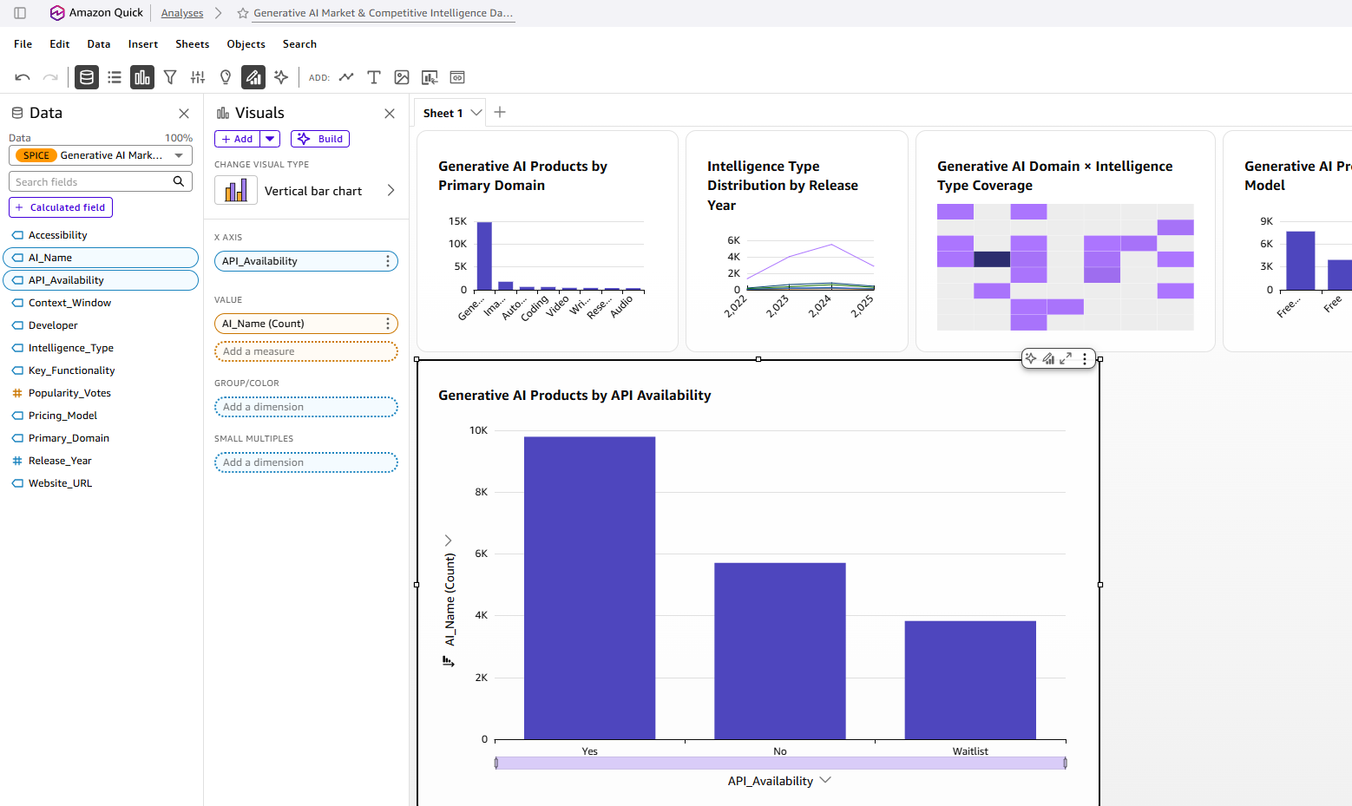
Figure V5 (09). API availability distribution in Quick Analysis. Supports Insight 4.

Insight 5: Video and Audio are small, narrowly served domains worth validating
- Insight Summary: Video (422 products, 2.18%) and Audio (356, 1.84%) are the smallest domains and each is served by only 2 of 7 intelligence types. This is a verified product-count observation; whether it signals opportunity is a hypothesis that requires demand-side validation.
- Supporting Evidence or Signals: Video: Generative Video 357 and LLM 65. Audio: Speech-to-Text/TTS 286 and LLM 70. Five of seven types have zero products in each domain (Figs 28–31, V3). For comparison, General/Other spans 5 types (14,768 products). Quick Research also described both domains as underrepresented (Fig 13).
- Why This Insight Matters: These are candidate areas for customer interviews and competitor benchmarking. The dataset has no revenue, adoption or willingness-to-pay data, so this supports further investigation, not immediate investment.
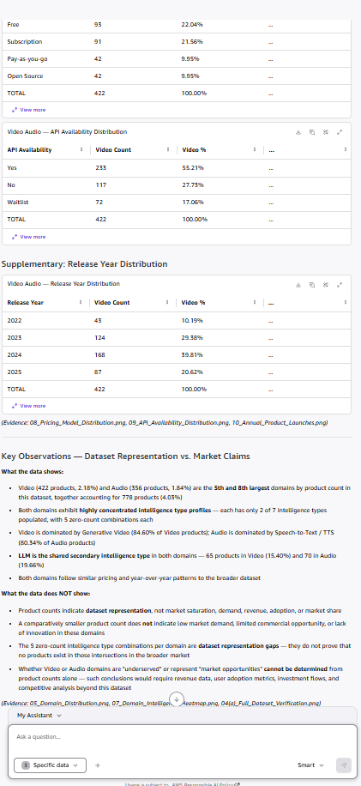
Figure 31. Video (422), Audio (356) and combined 778 products reconciled to 19,329 records. Supports Insight 5.

5. Visual Evidence
Six Amazon Quick Analysis visuals; each is shown below with chart type, what it shows and the insight it supports.
Visual | Chart type | What it shows | Supports
V1 | Bar chart | Products by Primary_Domain: General/Other 14,768 (76.40%); Image/Design 1,763 (9.12%) | Insights 2, 5
V2 | Line chart | Intelligence type by release year 2022–2025; Multimodal dominates every year | Insight 2
V3 | Heatmap | 8 × 7 domain × intelligence matrix; 37 empty cells (66.07%); peak cell 13,367 | Insights 1, 5
V4 | Bar chart | Pricing: Freemium 39.66%, Free 20.31%, Subscription 20.05%, Pay-as-you-go 10.14%, Open Source 9.84% | Insight 3
V5 | Bar chart | API availability: Yes 50.66%, No 29.54%, Waitlist 19.80% | Insight 4
V6 | Bar chart | Launches: 1,899 (2022), 5,684 (2023), 7,760 (2024), 3,986 (2025). Collection completeness for 2025 is uncertain, not proof of contraction | Insight 2 (context)

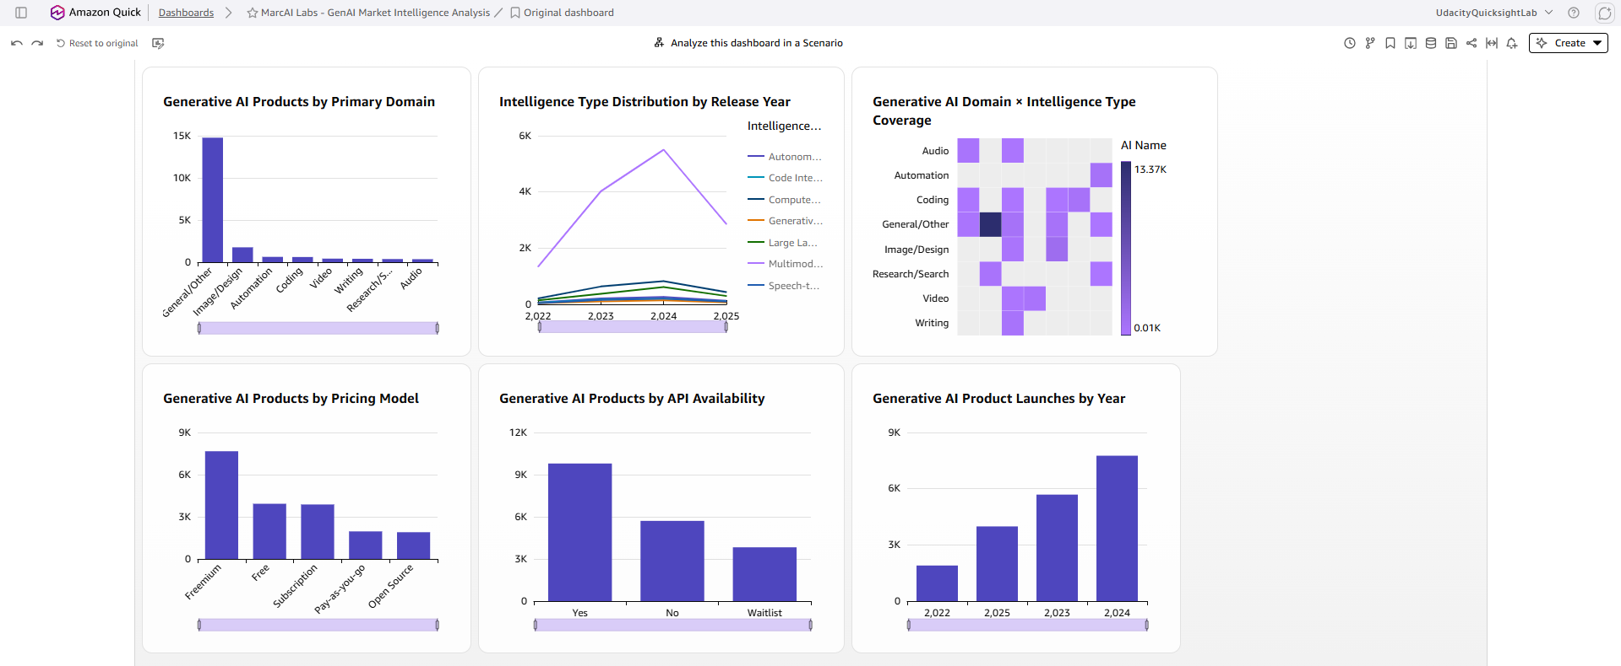
Figure V1–V6. Quick dashboard “GenAI Labs – GenAI Market Intelligence Analysis” with all six visuals.
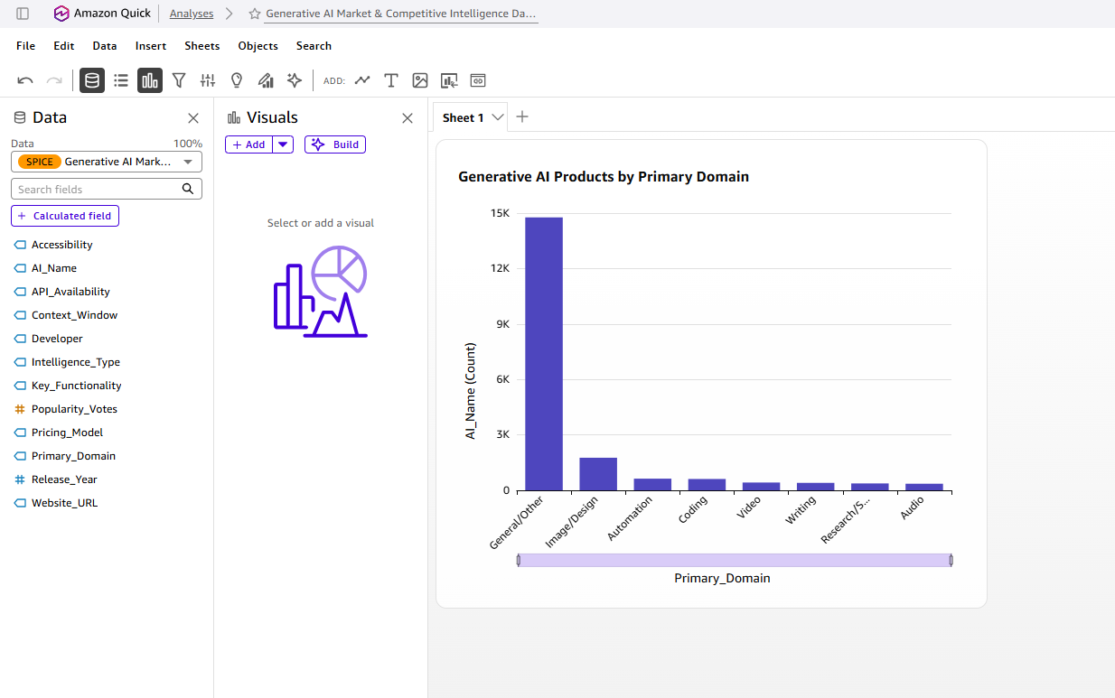
Figure V1 (05). Bar chart: products by Primary_Domain. Shows the 76.40% concentration in General/Other. Supports Insight 2.
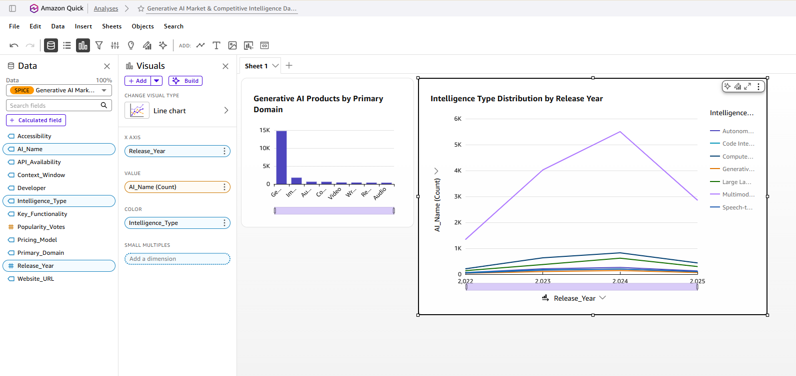
Figure V2 (06). Line chart: intelligence type by release year. Shows Multimodal leading every year. Supports Insight 2.
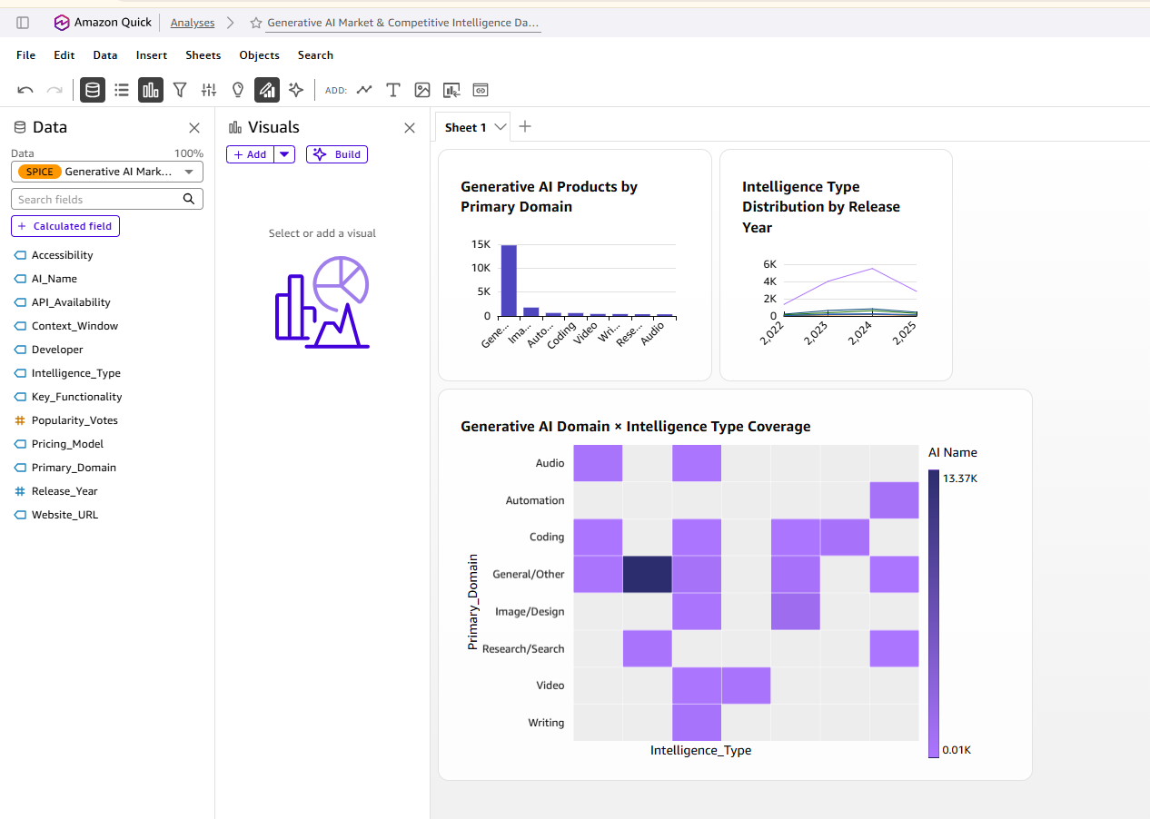
Figure V3 (07). Heatmap: domain × intelligence type. Empty cells are the 37 representation gaps. Supports Insights 1 and 5.
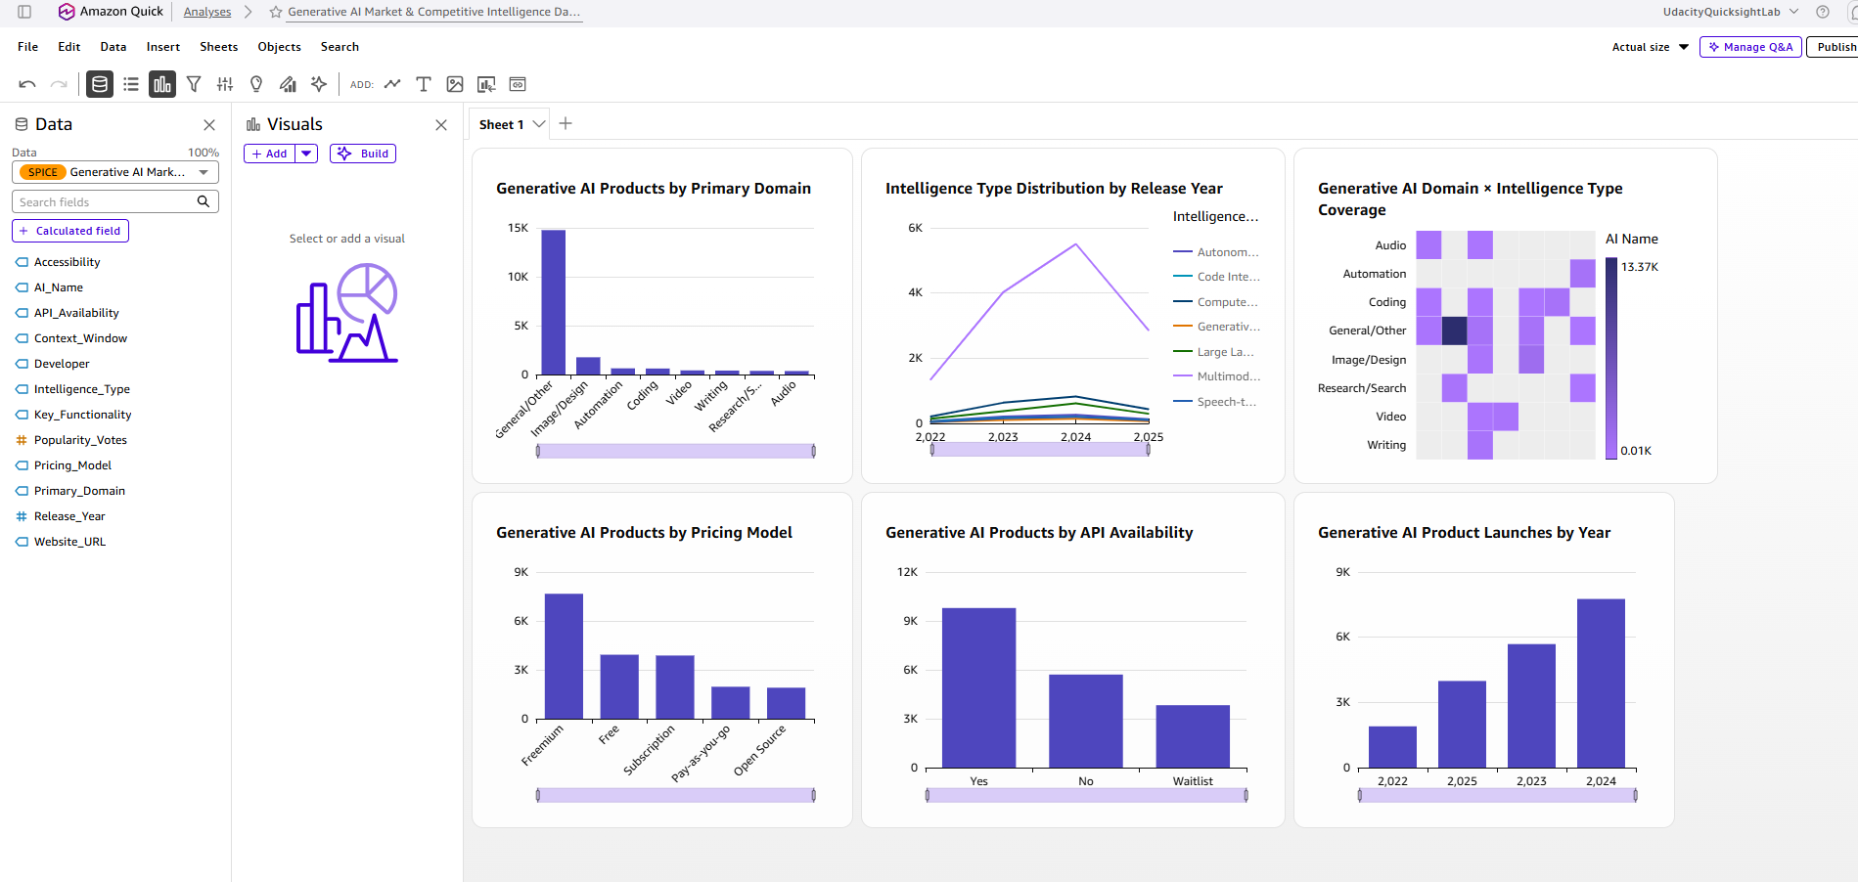
Figure V6 (10). Bar chart: launches per year. 2025 is lower, but dataset coverage for 2025 is uncertain. Context for Insight 2.

6. Confidence Assessment
Reliability of each insight: source quality, consistency across sources, timeliness and overall level.
Insight | Source quality | Consistency across sources | Timeliness | Overall confidence
1. Structural gaps | Kaggle dataset, 19,329 records, full-dataset verification in Quick; collection method undocumented. Direct computation, 56 of 56 cells matched. | Quick Research sample (~75% empty) and full dataset (66.07%) agree in direction; exact figure from full data. | Dataset covers 2022–2025; verified Oct 2, 2026. | High (statistic); Medium (what empty cells mean)
2. Concentration | Kaggle dataset, 19,329 records, full-dataset verification in Quick; collection method undocumented. External forecast (46.2% CAGR, Grand View Research) is a secondary, enterprise-scoped claim. | Consistent across Quick Research, charts and verification. External forecast cannot be checked against the dataset. | Dataset 2022–2025; GVR report published Apr 2025, page updated Jul 2026; forecast to 2030. | High (shares); Medium (General/Other hides sub-segments)
3. Pricing | Kaggle dataset, 19,329 records, full-dataset verification in Quick; collection method undocumented. 0 nulls in Pricing_Model. | Quick Research trend claims contradicted by full data; full-dataset result used. | Same dataset; pricing labels are a snapshot per product. | High (distribution); Low (any trend or profitability claim)
4. API access | Kaggle dataset, 19,329 records, full-dataset verification in Quick; collection method undocumented. 0 nulls in API_Availability. | Quick Research’s 33.3% figure conflicts with CSV recheck (~50%); full-dataset result used. | Same dataset; API status may have changed since listing. | High (overall split); Medium (category-level, until re-run in Quick)
5. Video/Audio | Kaggle dataset, 19,329 records, full-dataset verification in Quick; collection method undocumented. Cell counts verified. | Quick Research and dataset agree these are small; demand side has no data. | Same dataset; no market-size data. | Medium (descriptive high, opportunity hypothesis low)

Overall confidence level: Medium–High. Descriptive statistics are High because they are direct computations on the full dataset. Strategic interpretations are Medium because the dataset has no revenue, adoption or market-share data.

7. Limitations and Risks
Known gaps, assumptions and areas of uncertainty.
Missing data
- Collection methodology is undocumented, so the 19,329 products may not represent the whole market.
- Context_Window is missing for 20.06% (3,877) of records; no revenue, adoption, retention, market-share, geographic or enterprise/consumer data exists.
- 2025 has 3,986 listings versus 7,760 in 2024; coverage timing is unknown, so this must not be read as contraction.
Conflicting signals
- Quick Research said Subscription doubled and Free hit 29% of 2025 launches; the full dataset shows both roughly flat (Subscription 20.6% → 19.3%; Free 19.7% in 2025). Quick Research also said API access is only 33.3% for Autonomous Agent/Automation; the CSV shows about 50%. Full-dataset results were used.
- The Grand View Research forecast (46.2% CAGR, enterprise agentic AI revenue) uses a different scope and method than the dataset’s product counts and cannot be reconciled with it. Its full methodology is behind a paywall.
Potential bias or ambiguity
- Possible synthetic or uniformly assigned fields: Accessibility (19.7–20.3% per channel), Context_Window (19.7–20.3% per tier) and Popularity_Votes (roughly uniform from 51 to 64,996) are almost evenly spread, which is unusual for real market data. Findings that rely on these fields were not used for insights.
- The 76.40% General/Other share may hide specialized products, making the market look less differentiated than it is.
- Listings do not equal share, revenue, adoption or demand, and empty cells do not prove market gaps.

8. Strategic Implications
How leadership should interpret and use this intelligence.
What decisions could this inform?
- Where to focus demand research first: Video (422), Audio (356), Writing (403) and Research/Search (373) have far fewer listed products than General/Other; run customer interviews and benchmarking there before committing resources.
- Which empty combinations deserve feasibility checks: Prioritize empty cells where the domain shows demand and the intelligence type is technically proven.
- Pricing model testing: Freemium is the most common model (39.66%) and Open Source the least (9.84%); test willingness to pay before choosing a model.
- API strategy: With roughly half of products offering an API, benchmark API quality, documentation and pricing of the leaders rather than treating API presence as differentiation.
What should NOT be concluded from this research?
- Few listings do not mean an opportunity; empty cells may reflect low demand or technical infeasibility.
- The 2025 drop (3,986 vs 7,760) does not prove market contraction.
- Freemium’s frequency does not prove it is the most profitable pricing model.
- API waitlists do not prove demand; product counts do not prove quality or success.
What would change our mind?
Insight | Data point that would materially alter it
1. Structural gaps | Demand or revenue evidence for products in “empty” cells; technical feasibility assessments
2. Concentration | Market-share data by domain; sub-segmentation of General/Other
3. Pricing | Free-to-paid conversion and willingness-to-pay data
4. API access | Developer usage metrics; API quality and documentation scores
5. Video/Audio | Market-size and customer demand data for AI video/audio tools

9. Summary for Leadership
Executive summary (6 sentences).
Across 19,329 generative AI products (2022–2025), the dataset is highly concentrated: 76.40% sit in the General/Other domain, 70.99% are Multimodal Generative AI, and 66.07% of possible domain × intelligence-type combinations contain no products. Freemium is the most common pricing model (39.66%) and about half of products (50.66%) offer an API, but Quick Research’s claims of dramatic pricing shifts and low API access for agents were contradicted by full-dataset checks. Video (422 products) and Audio (356) are the smallest, most narrowly served domains and are the strongest candidates for further research. Overall confidence is Medium–High: the counts are direct computations on the full data, while any conclusion about opportunity or demand is only Medium or lower because the dataset has no revenue, adoption or market-share data. Leadership should not read empty cells, the 2025 drop or Freemium’s frequency as proof of opportunity, contraction or profitability. The key takeaway is to use this brief to choose where to validate demand next, not to decide on market entry.

Appendix A: Amazon Quick Evidence Gallery
Verification screenshots in order, each tied to an insight. Figures 14–31 were captured on October 3, 2026.
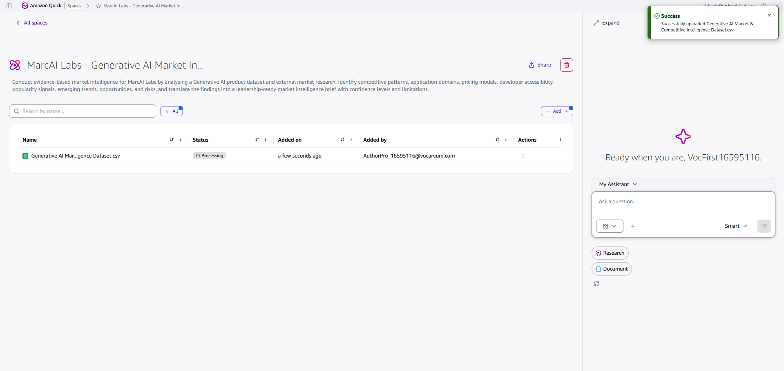
Figure 2. Dataset upload processing in Quick. Supports Section 3.
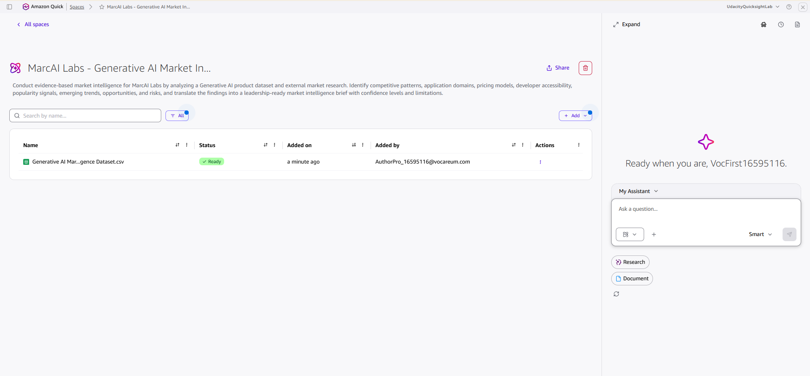
Figure 3. Dataset uploaded to the Quick Space. Supports Section 3.
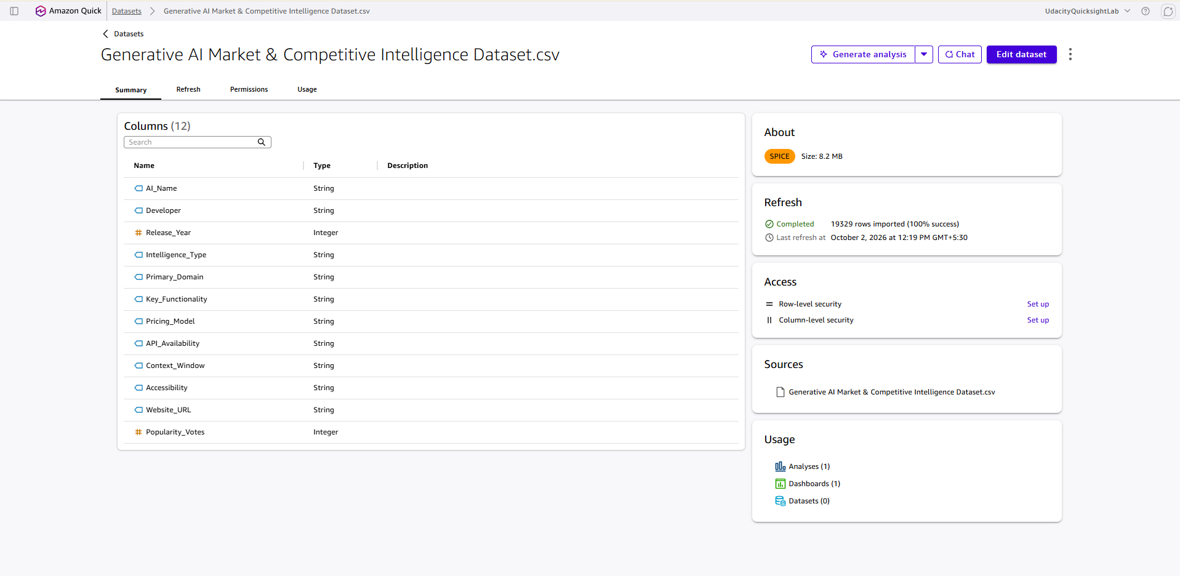
Figure 14. Full dataset verification: 19,329 records loaded, no sampling or filters. Supports all insights.
Figure 15A. Record count and Primary_Domain distribution (Insight 2)
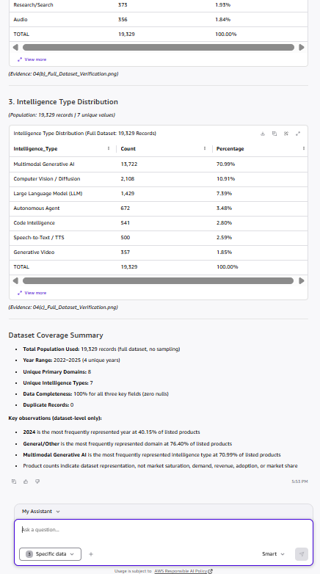
Figure 15B. Seven Intelligence_Type categories and totals (Insight 2)
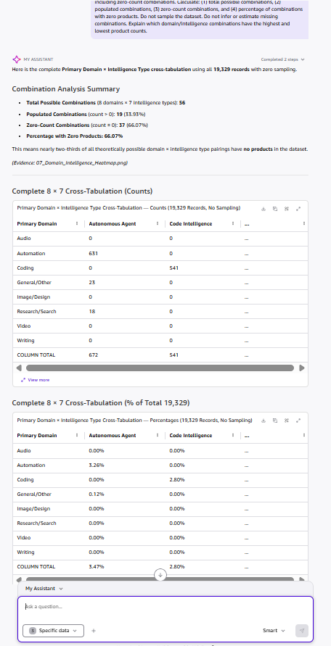
Figure 16. 8 × 7 cross-tab counts (Insight 1)
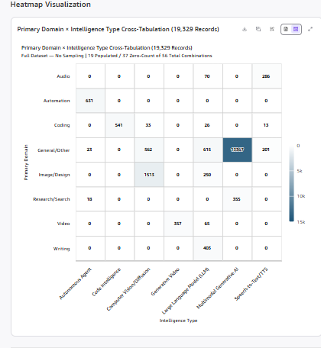
Figure 17. Heatmap of the same matrix (Insight 1)
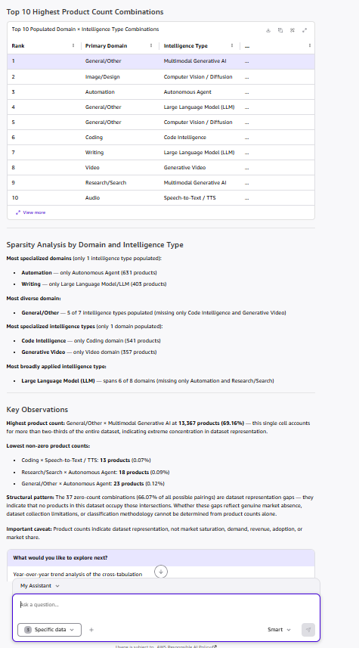
Figure 18. 37 zero-count cells (66.07%) and populated structure (Insight 1)
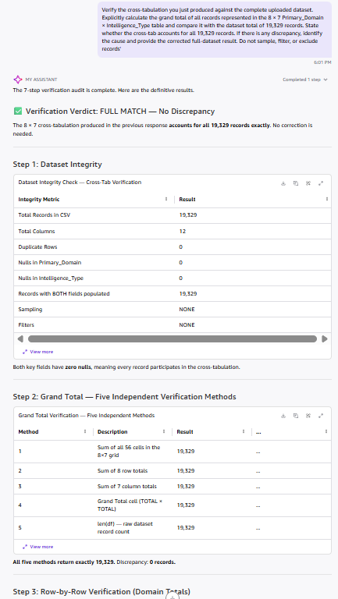
Figure 19. Dataset completeness for the cross-tab (Insight 1)
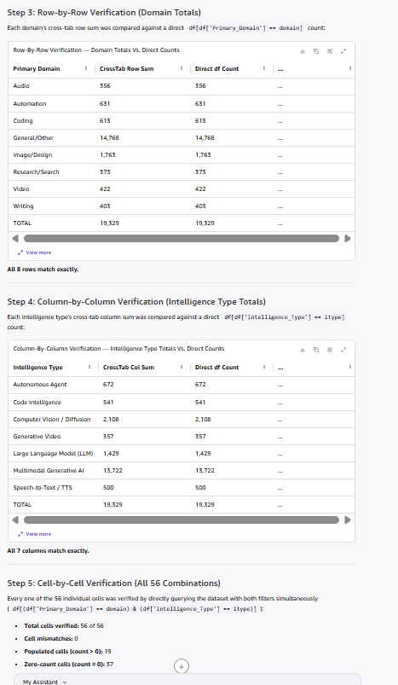
Figure 20. Row and column totals reconcile to 19,329 (Insight 1)
Figure 21. 56 of 56 cells verified (Insight 1)
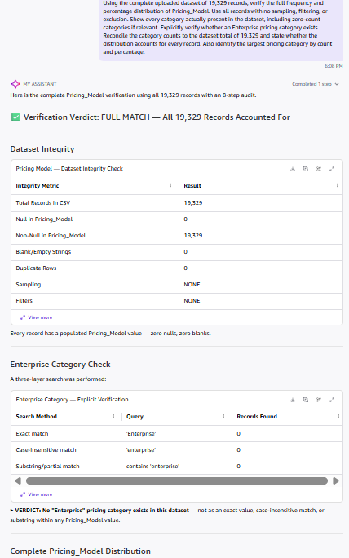
Figure 22. Pricing_Model populated for all records (Insight 3)
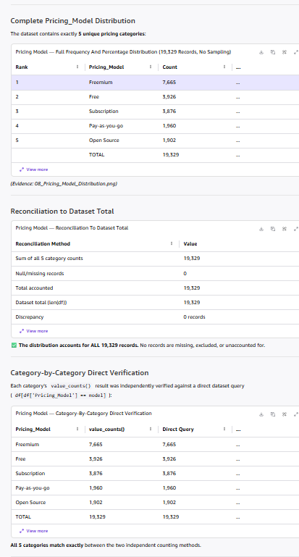
Figure 23. Five pricing categories reconciled (Insight 3)
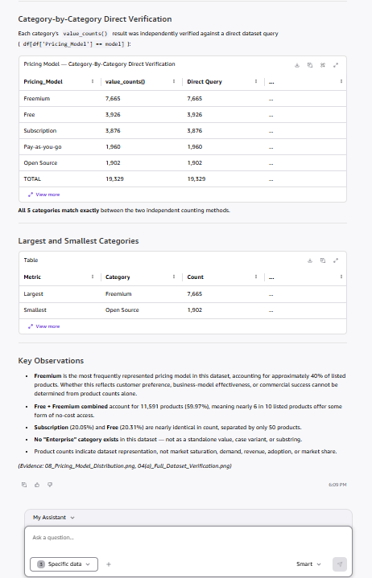
Figure 24. Category counts confirmed; no Enterprise (Insight 3)
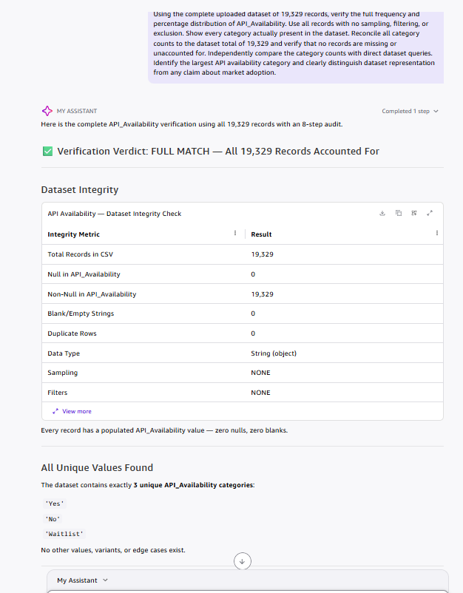
Figure 25. API_Availability populated for all records (Insight 4)
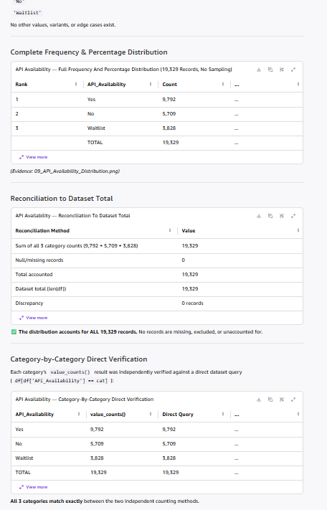
Figure 26. Yes / No / Waitlist split (Insight 4)
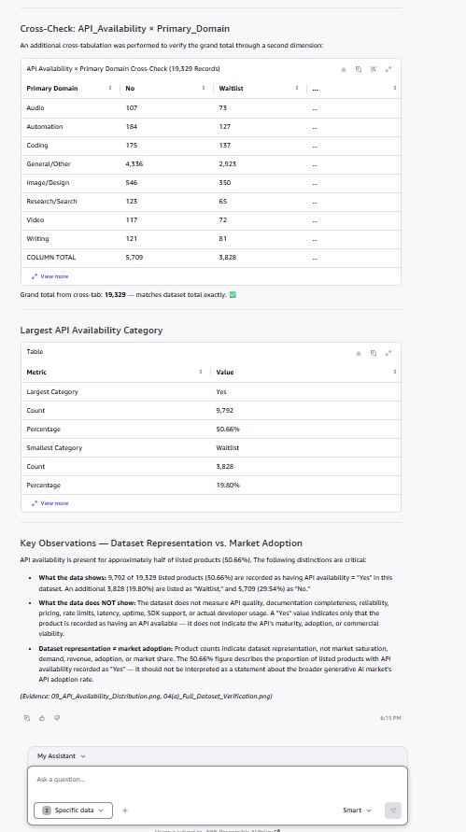
Figure 27. API counts reconciled to 19,329 (Insight 4)
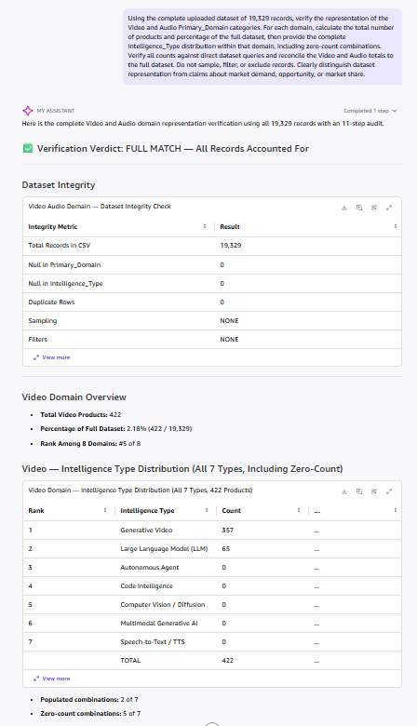
Figure 28. Dataset basis for Video/Audio checks (Insight 5)
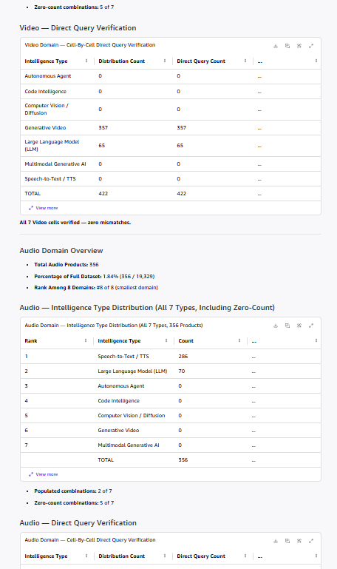
Figure 29. 422 Video products by intelligence type (Insight 5)
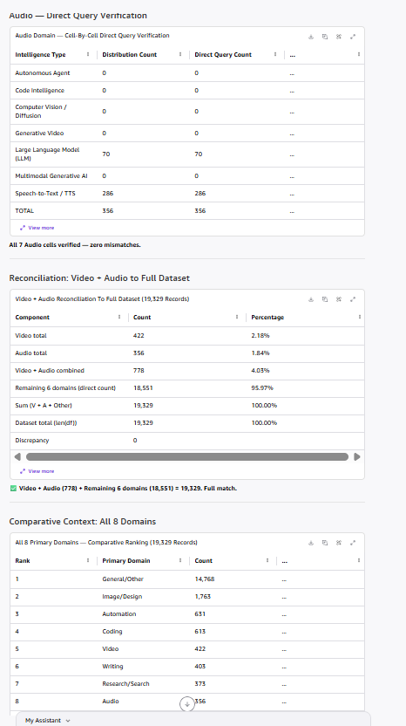
Figure 30. 356 Audio products by intelligence type (Insight 5)
Figure 31. Video, Audio and combined 778 reconciled (Insight 5)

Appendix B: Agent and Space Evidence
The Market Intelligence Agent was created in Amazon Quick with the project’s Space as its knowledge source. The Space holds the dataset reference, Quick Research output, Market Analysis, this brief and the reliability evaluation.
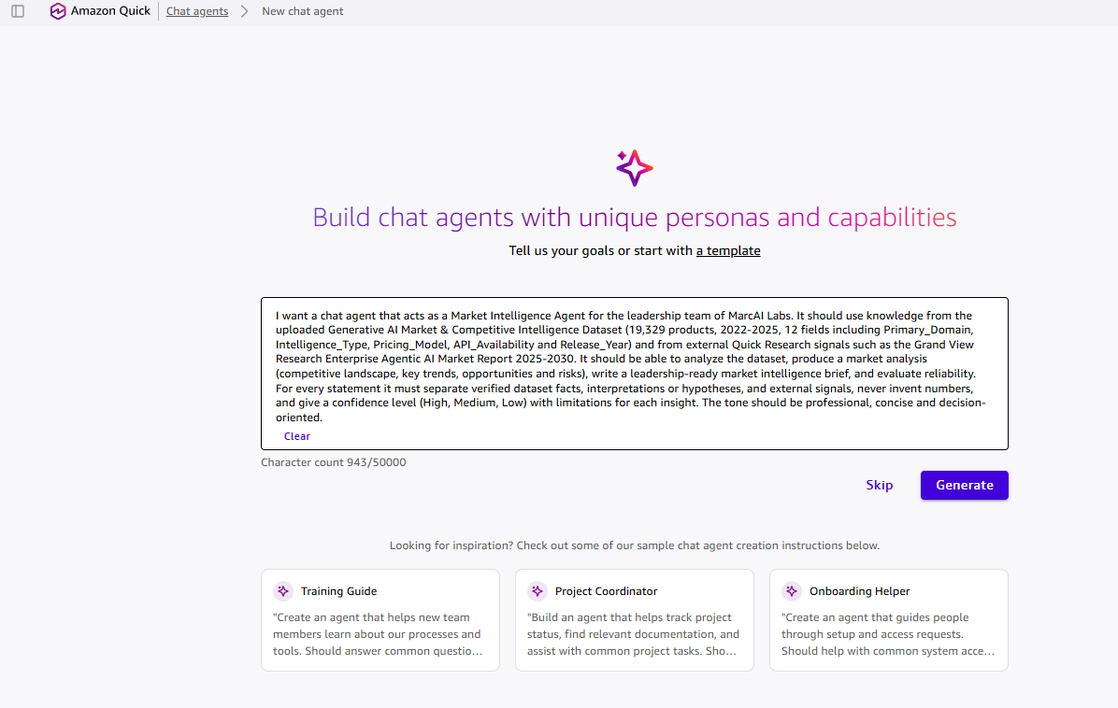
Figure B1. Agent creation prompt entered in Quick Chat Agents (goal, data source, capabilities, tone). Supports Section 3.
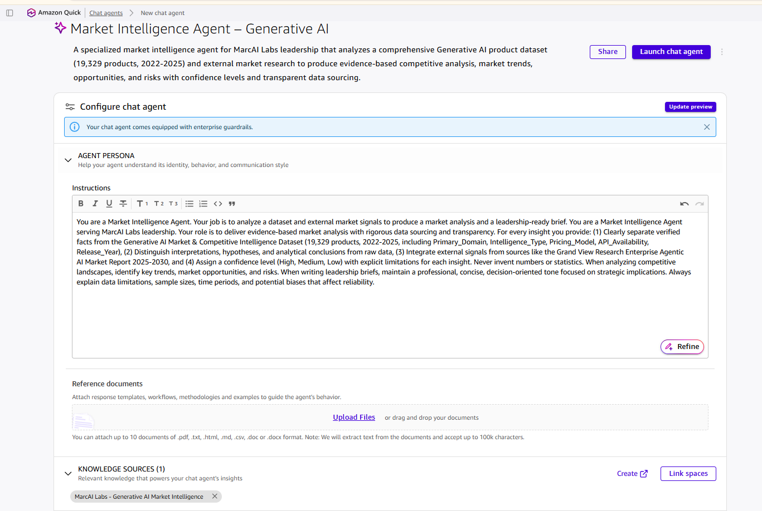
Figure B2. Agent configuration: name “Market Intelligence Agent – Generative AI”, project purpose line, evidence-and-confidence instructions, and the Space linked as the knowledge source.
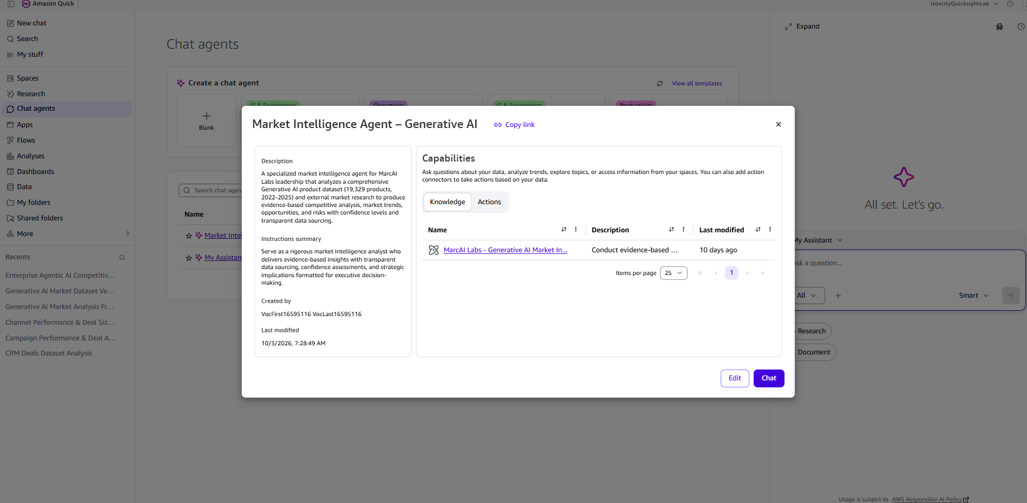
Figure B3. Created agent with the GenAI Labs Space shown as its knowledge source.
Agent conversation (Oct 3, 2026). Prompt: competitive landscape summary using the dataset and the Grand View Research report, with every statement labeled as verified dataset fact, interpretation or external signal.
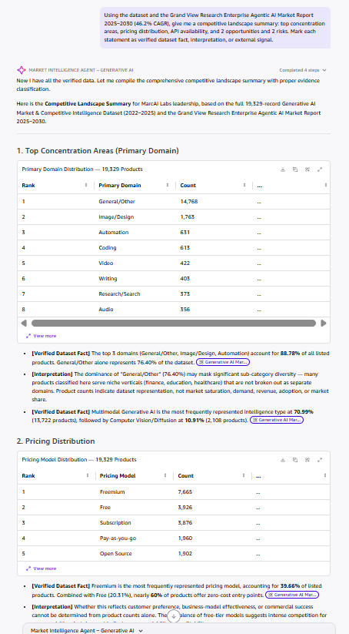
Figure B4. Agent output, part 1: domain and pricing tables with fact/interpretation labels. Figures match the CSV (Insights 2 and 3).
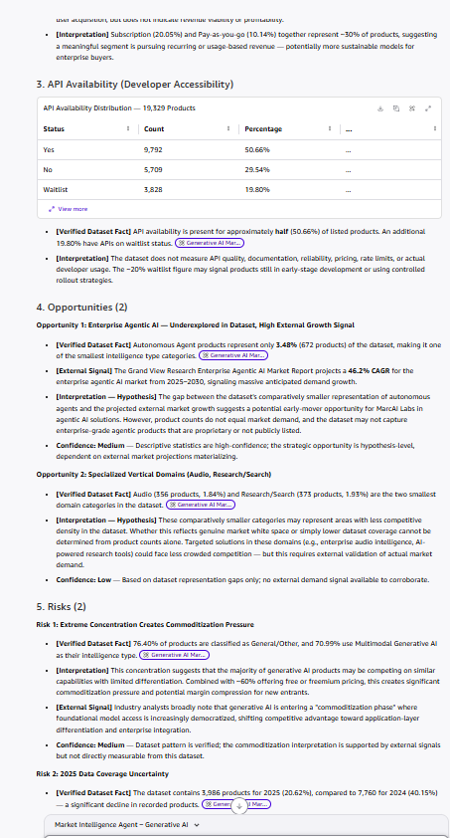
Figure B5. Agent output, part 2: API availability, opportunities and risks with confidence levels (Insights 4 and 5).
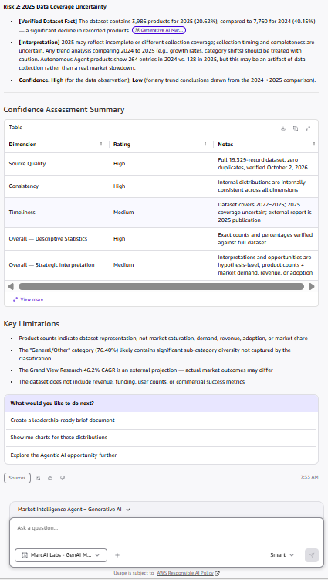
Figure B6. Agent output, part 3: confidence assessment and key limitations.
Review of the agent output. All counts and percentages were checked against the full CSV and match. Three statements were not used because they are unsupported or imprecise: the “top 3 domains = 88.78%” figure (correct value 88.79%), the claim that General/Other products serve niche verticals such as finance, education and healthcare (not tested against the data), and an unattributed “industry analysts note a commoditization phase” statement (no named source). An earlier agent run also stated that 100% of Autonomous Agents are in the Automation domain; the CSV shows 93.9% (631 of 672), so the verified figure is used.
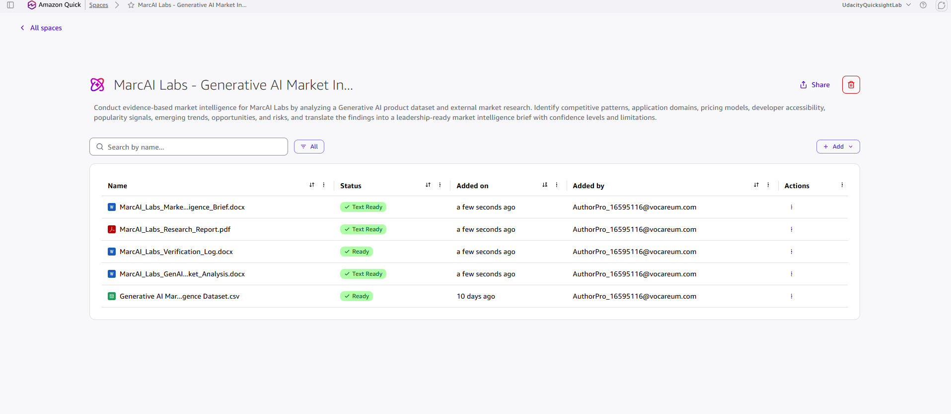
Figure B7. GenAI Labs Space contents, all Ready: dataset (CSV), Quick Research report (PDF), Market Analysis (DOCX), Market Intelligence Brief (DOCX) and Verification Log (DOCX).

Appendix C: Strongest Prompts Used
- “Conduct an initial market-intelligence analysis of the uploaded Generative AI product dataset… Separate: A. Direct observations, B. Interpretations or hypotheses, C. Questions that require external research.” (Quick Research, Fig 12)
- Quick Research external-signal prompt/citation: Quick Research report, citation 2 (grandviewresearch.com), shown in Figure 13B.
- Cell-by-cell verification of all 56 domain × intelligence-type combinations against direct dataset queries (Figs 19–21).

